**SQL**

1.Create database

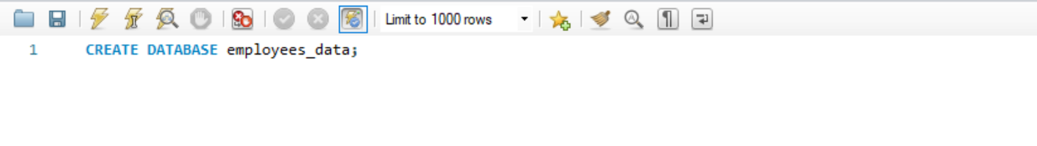

2.create table

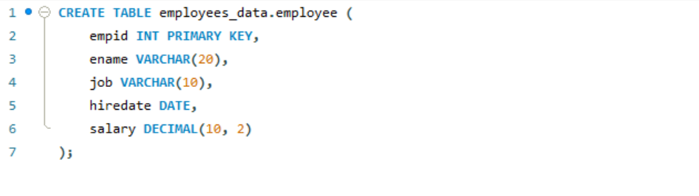  
3.Insert  
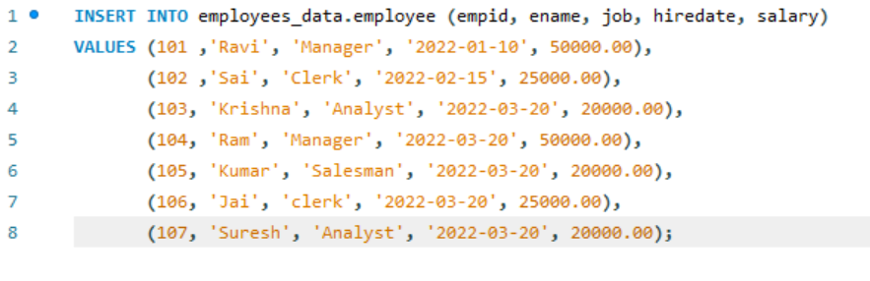

4.Update  
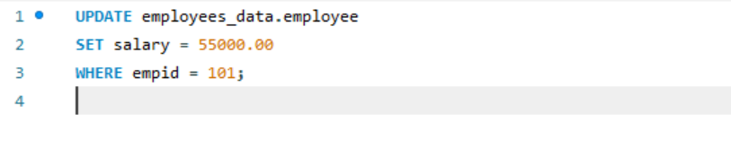

5.Delete  
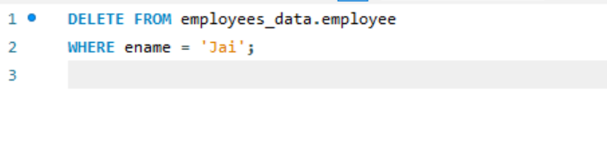

6.Count total employees  
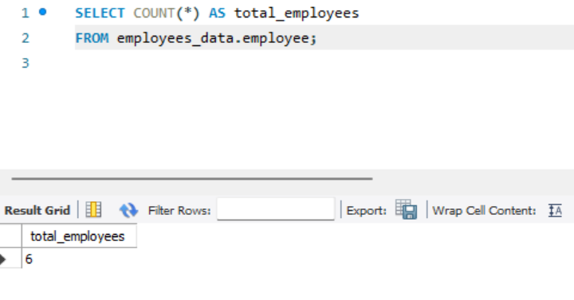

7.Average salary of employees

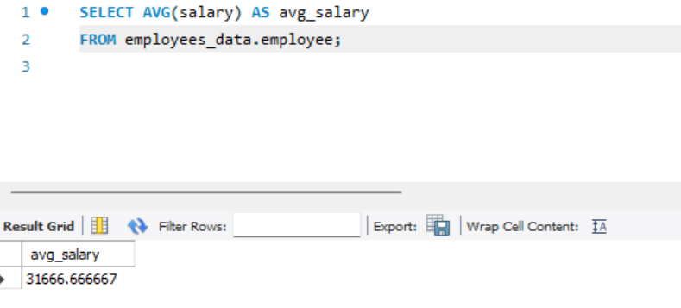

8. Count employees hired between 2022-01-01 to 2022-02-28

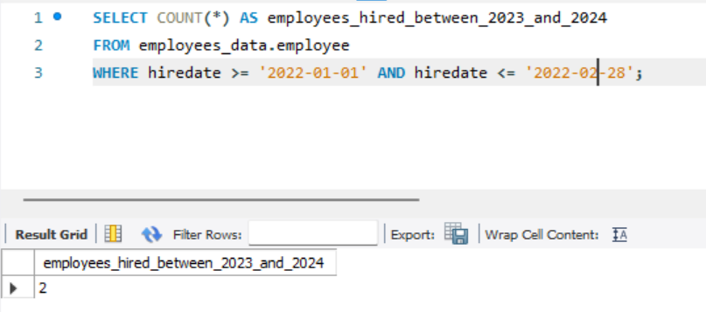

9. Count employee who's job is manager

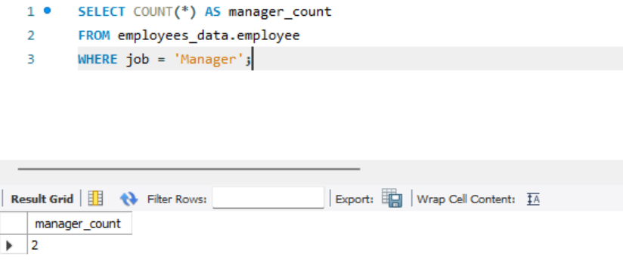

**Joins**

Employee table 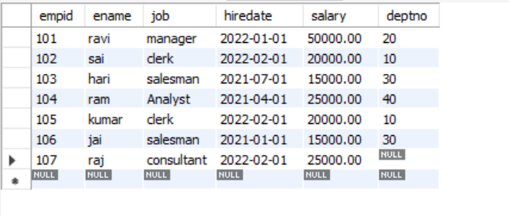

Department table 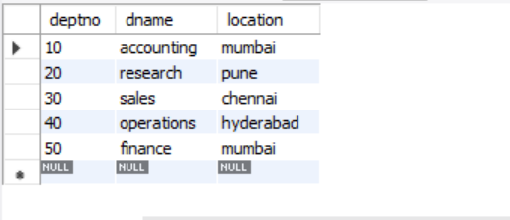

1.Inner Join 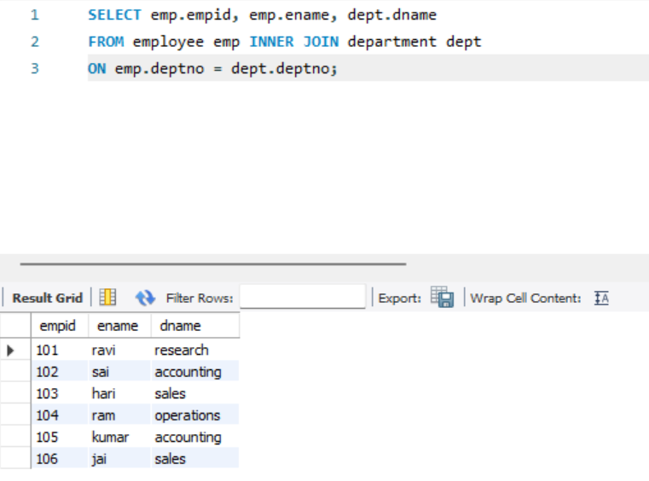

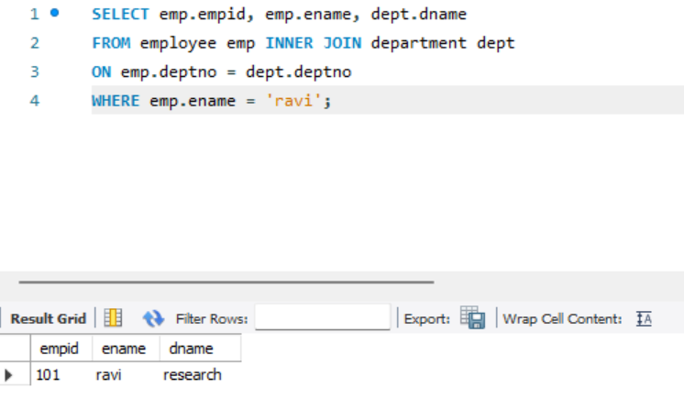

**2.Outer Join**

Left outer join

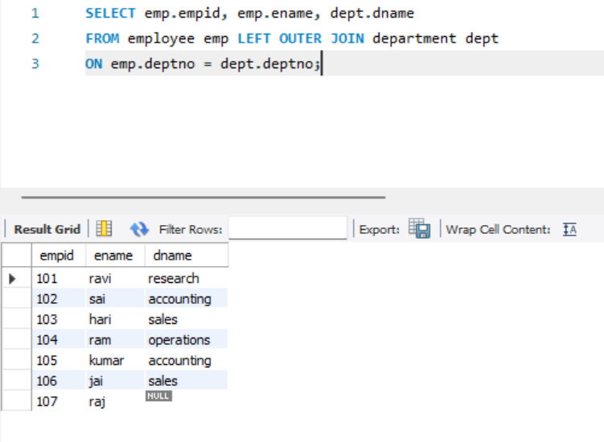

Right outer join 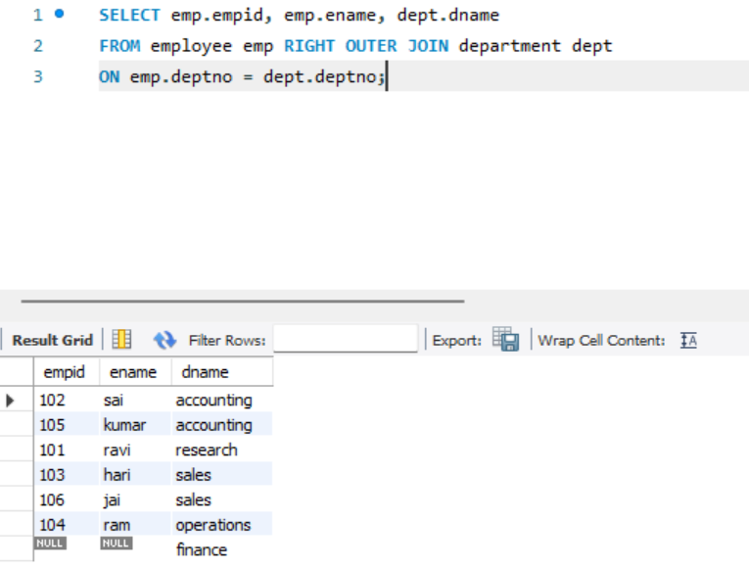

Full outer join(In Mysql Full outer join is achieved using uninon) 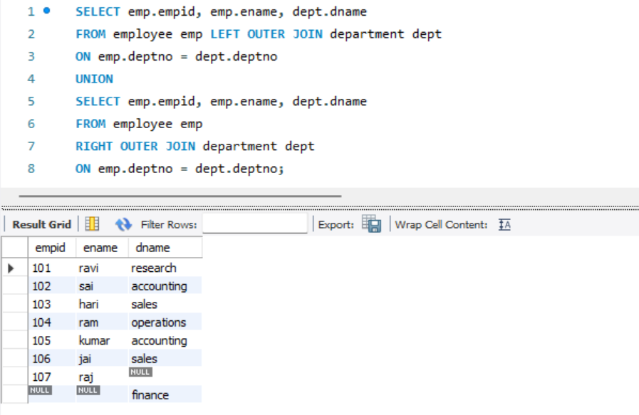

3.Union

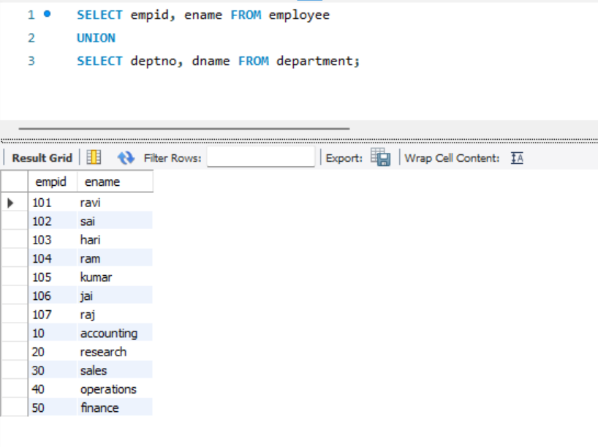

4.Intersect(In Mysql Intersect is achieved using Inner join)

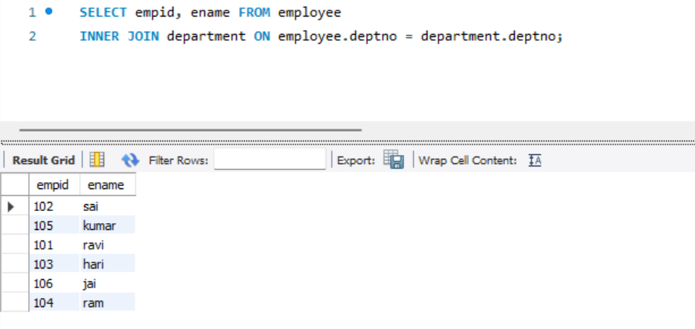

5.subqueries 